IVY TECH COMMUNITY COLLEGE
SDEV 140 / Introduction to Software Development
S13 Software Development Lab 4 / (25 points)

Student’s name ______________________ Section _______ Instructor’s name _________________

INTRODUCTION: In this assignment, you will perform bench tests on the order form program, create a User Guide for the program, explaining to a beginner how to run the program, and expand the DroneDogs program in response to a Software Project Enhancement Request, by designing a new form for adding and selecting customers.

There are three parts to the assignment. In Part 1, you will perform and record bench test using the Bench Test Guidelines below. In Part 2, you will create a User Guide for the DroneDogs system, using the User Guide Guidelines below (this will be submitted as a separate document). In Part 3, you will name the components on the new Customer Information form and the added controls on the Order Input form.

ASSIGNMENT PART 1:

Perform and document bench tests on the DroneDogs order form program, using the Bench Test Guidelines below, and typing in your answers in where requested.

BENCH TEST GUIDELINES:

- Below are the numbers for 10 orders: the number of beef dogs, pork dogs, and turkey dogs.
- Start your DroneDogs Order Input form program in Visual Basic by selecting Deubg / Start Without Debugging.
- Get a watch with a second hand, and when you are ready to start, write down the exact Starting Time in the blank provided below the numbers.
- Enter each of the 10 orders, clicking Calculate Order and Submit Order after each one, and write down the total cost for each order after you click the Submit Order button.
- After the 10th order, write down the Ending Time from your watch, calculate the Elapsed Time, and the Average Time Per Order (multiply the number of elapsed minutes by 60, add the number of seconds, and divide by 10).

# Beef dogs # Pork dogs # Turkey dogs Total cost (type in)
1 2 3 $
5 3 1 $
3 1 0 $
10 0 0 $
2 4 6 $
0 8 1 $
4 3 2 $
1 1 1 $
6 0 2 $
0 0 1 $

Starting Time (hh:mm:ss):
Ending Time (hh:mm:ss):
Elapsed Time (in minutes and seconds):
Average Time Per Order (divide total seconds by 10):

ASSIGNMENT PART 2:

Create a User Guide for the order form program, using the User Guide Guidelines below, and the document S13_UserGuide.docx.

USER GUIDE GUIDELINES: You are to create a User Guide for the DroneDogs program, describing to a user how to order hot dogs from DroneDogs using the program you have created in Visual Basic. Open the file S13_UserGuide.docx, and use that file to create your User Guide.
- You may change the styles, fonts and layouts of the user manual, but it is suggested that you do that by changing the Styles in the document (Title, Subtitle, Heading 1, Heading 2, Normal, etc.), and using those styles consistently in your document.
- The User Guide should include an Introduction section, which describes the ordering process in a narrative form, and a Directions section, which takes the user step-by-step through the ordering process.
- You can assume that the program is available on the DroneDogs website, or as a mobile app, and that the user knows how to find the program.
- Assume that the user has basic computer skills (they know how to start the program, and how to use the mouse and keyboard), but has never seen the DroneDogs Order Input form before.
- Be sure to cover things like entering a 0 instead of leaving a text box blank, in what order to enter numbers and click buttons. After stating the steps to place and calculate and order, be sure to include how to exit the program.
- Spell-check your User Guide, and proofread it for accuracy and clarity. It is suggested that you have someone else run your program using your User Guide and ask them for improvements in the instructions.
- When you are convinced that the User Guide is accurate, clear, and attractive-looking, save it again. You will be submitting the User Guide, in addition to this document.

ASSIGNMENT PART 3:

Read the S13 Software Development Project Enhancement Request (in Blackboard Session 13). Then, name the new controls on the Order Input form and all the controls on the new Customer Information form below.

The order form for DroneDogs is displayed below with some added fields, and a new customer form has been added. Each of the controls has an identifying letter. Using Hungarian Notation prefixes, type the name you would assign to each control.

Notes: The small box at the bottom of the order form is a CheckBox (the text is a property of the CheckBox, not a label), and the large box near the top of the customer form is a ListBox. Also, you can use the same names for the First Name, Last Name and Email controls on both forms.

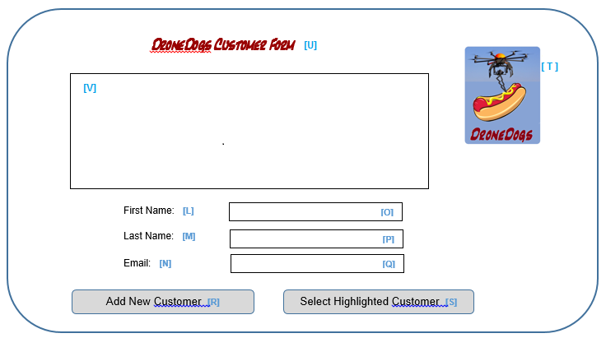
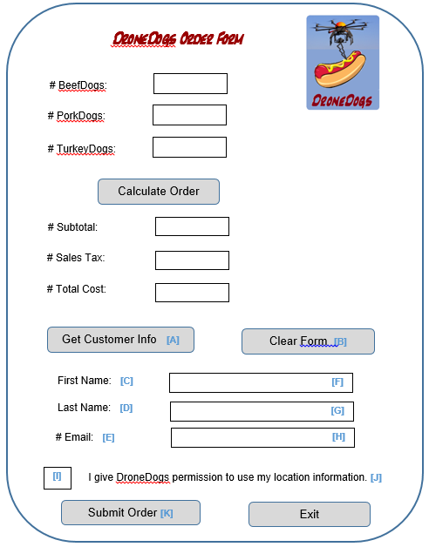

Enter the control names you would assign, using Hungarian Notation:

A:
B:
C:
D:
E:
F:
G:
H:
I:
J:
K:
L:
M:
N:
O:
P:
Q:
R:
S:
T:
U:
V:

WHAT TO SUBMIT:
  - This document (S13_SDEV_Lab4.docx), with:
    - The Bench Test information filled in (10 pts), and
    - The Customer Information form and new Order Input form controls named (5 pts)
  - The User Guide (S13_UserGuide.docx), as a separate document (10 pts)

